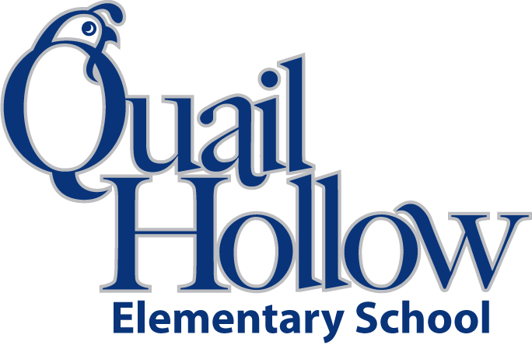

**List of Items Your Child Needs:**

* Change of clothes (including socks & underwear)
* Small blanket for rest time (**Please no pillows, sleeping bags or**

**large blankets)**

* back pack **(please no book bags with wheels)**
* 1 4X6 family picture that will be laminated and put up in the class for the year

**List of Donated Items we can use:**

* Gallon/quart/sandwhich size Ziploc bags
* Velcro or magnetic tape with sticky back (Walmart)
* Washable Crayola markers
* Crayola crayons
* Elmer’s glue sticks
* Elmer’s glue bottles
* White copier paper
* Dry erase markers
* AA/AAA batteries
* Art crafts supplies (fun fabric, foam shapes, buttons, sequins, ribbon, pom poms etc.)

Headstart Supply List 2019-2020

K