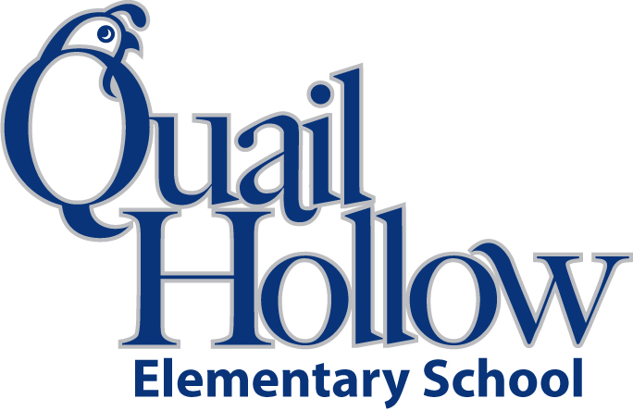

4th Grade 2019/20 Supply List

3 boxes of pencils

2 boxes of tissues

5 Composition Notebooks

2 highlighters

3 packages of dry erase markers

3 rolls of clear tape (transparent or dispenser)

5 – plastic, double pocket folders, with prongs (any color)

Lysol wipes

Pencil Pouch or Pencil Box

scissors

Sticky Notes (any color)

1 set of earbuds (place in a Ziploc with child’s name)

Boys only:

* 1 box of sandwich size resealable baggies
* 1 package of crayons

Girls only:

* 1 box of gallon size resealable baggies
* 1 box of colored pencils

4th Grade Supply List 2019-2020

K