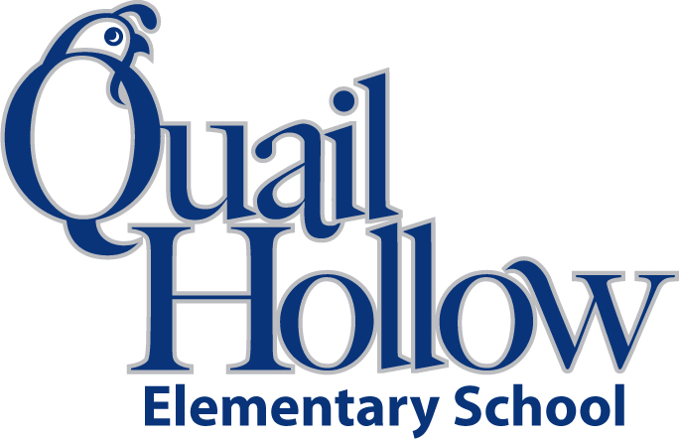

* Backpack with Child’s Name On It (Please No Wheels)
* Earbuds (**place in a baggie labeled with child’s name)**
* (2) 24 **Crayola** crayons (The name brand does make a difference)
* **ELMER’s** glue sticks (The name brand does make a difference)
* 1 Pair of scissors (Label with your child’s name)
* 3 Plastic 3-Prong Pocket Folders (Blue, Red, and Green) **(Label with your child’s name)**
* Pencil box (Label with your child’s name)
* Tissues boxes (2)
* Composition notebook (2) (**black and white only**)
* 1 Pack of **BLACK** Expo Markers
* 1 Box of Magic Erasers
* Baby Wipes
* 1 black felt square (You can get them in the craft section)

Boys please bring:

* 1 Box of Snack Size Ziploc Bags

Girls please bring:

* 1 Box of gallon Size Ziploc Bags

**ALL STUDENTS MUST have an extra set of clothes and undergarments.** We do have occasional accidents and spills.

All items will be the community property of the class excluding

backpacks, pencil boxes, and ear buds.

**PLEASE purchase a box of crayons, glue stick, and scissors for home. You will need them for homework.**

Kindergarten Supply List 2019-2020

K