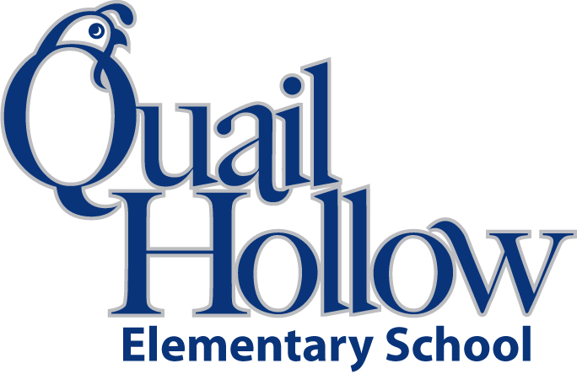

- Ear buds or headphones (place in a baggie with child’s name)

- 3 packages of #2 pencils

- 5 3-hole pocket folders

- 12 Expo dry erase markers

- 1 package of pencil-top erasers

- 5 spiral 1 subject notebooks

- Pencil box/ pouch

- 8 glue sticks

- 1 roll Paper Towels

- 1 package Crayola Markers

- 1 package Crayola Colored Pencils

- 1 pair of scissors

Boys only:

* 1 bottle of hand sanitizer

Girls only:

* 2 boxes of tissues

5th Grade Supply List 2019-2020

K