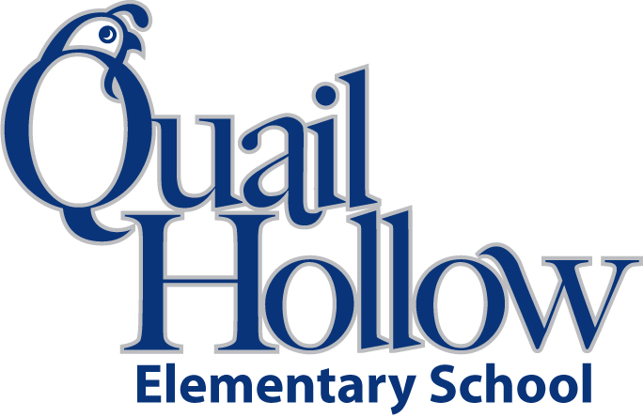

* 3 composition notebooks (wide ruled)
* 1 notebook paper (wide ruled)
* 1 binder (3 ring, 1 inch, plastic)
* 6 folders with prongs (1-red, 1-blue, 1- green, 1-orange, 1- yellow, 1-purple)
* 1 scissors (youth size)
* 2 packs of crayons (variety color)
* 1 pencil bag/box (any color)
* 1 pack of glue sticks
* 3 large block erasers
* 1 ear buds (place in a baggie with child’s name)
* 2 packs of dry erase markers
* 2 packs of sticky notes (any color)
* 2 packs of pencils (yellow, #2)
* 1 package of index cards
* 1 box of tissues
* 1 bottle hand sanitizer

Boys only:

* 1 box of quart size baggies
* 1 package of markers

Girls only:

* 1 Lysol wipes
* 1 box of colored pencils

2nd Grade Supply List 2019-2020

K