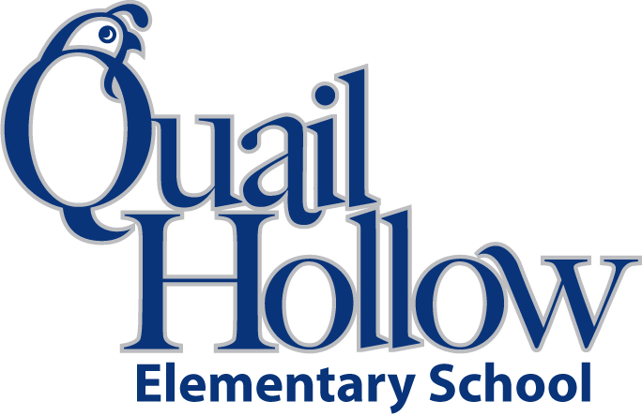

* Backpack with Child’s Name On It (Please No Wheels)
* 1 Box of Crayons (24ct)
* 3 pkgs. of Erasers – large pink rectangular – no cap erasers
* 24+ #2 Pencils (Sharpened Please)
* 1 Highlighter
* 2 Packs of Black Expo Dry Erase Markers
* 1 Black Composition Notebooks with Primary Writing Lines
* 2 Wide-ruled spiral notebooks
* 3 **Plastic** 3-Prong Pocket Folders (Blue, Red, and Green)
* 2 bottles of hand sanitizer
* 2 boxes of Kleenex
* 1 box of quart size Ziploc Bags
* 1 box of gallon size Ziploc Bags
* 1 container of Clorox Disinfecting Wipes
* 1 box Mr. Clean or Magic erasers

All items will be the **community property** of the class excluding the backpack. For this reason, please **do not write your child’s name** on the school supplies.

Thank you,

First Grade Team

1st Grade Supply List 2019-2020