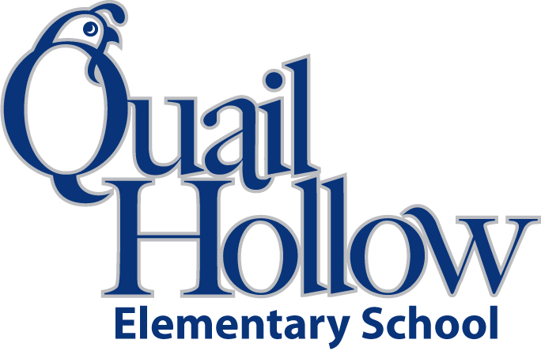

All items will be the community property of the class excluding

backpacks, pencil boxes, and ear buds.

PLEASE purchase a box of crayons, glue stick, and scissors for home. You will need them for homework.

* Backpack with Child’s Name On It (Please No Wheels)
* 24 Crayola crayons (2)
* Pair of scissors (1) (Label with your child’s name)
* 3 Plastic 3-Prong Pocket Folders (Blue, Red, and Green) (Label with your child’s name)
* Pencil box (Label with your child’s name)
* Tissues (2)
* Composition notebook (2) (**black and white only**)
* 1 Pack of BLACK Expo Markers
* 1 Box of Magic Erasers
* Baby Wipes
* Earbuds (**place in a baggie labeled with child’s name)**

Boys please bring:

* 1 Box of Snack Size Ziploc Bags

Girls please bring:

* 1 Box of gallon Size Ziploc Bags

Kindergarten Supply List 2018-2019

K