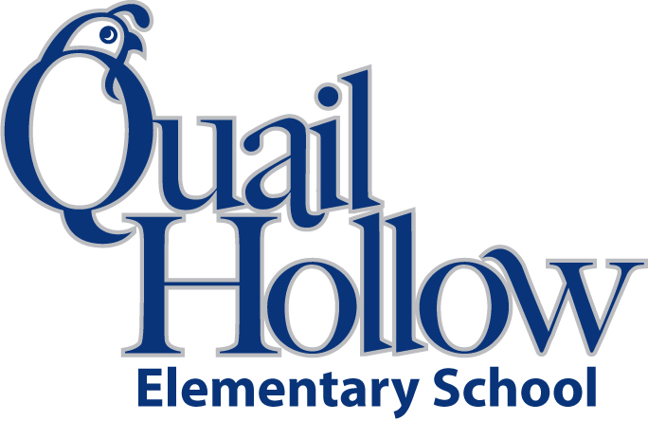

- 1 1 inch 3-ring binder

- 1 set of dividers for binder

- ear buds/ headphones (place in a baggie with child’s name)

- 2 packages of #2 pencils

- 5 3-prong pocket folders

- 4 white board markers

- 1 white board eraser or new sock

- 1 pack of washable markers

- 1 pack of colored pencils

- 1 handheld pencil sharpener

- 1 or 2 pink erasers or 1 package of pencil-top erasers

- 1 box of crayons

- 1 package of colored pens (variety)

- 3 highlighters (different colors)

- 5 Composition notebooks

- 1 pencil box

- 8 glue sticks

- 1 child safe pair of scissors

- 1 bottle of hand sanitizer

- 1 box of tissues

Boys only:

Quart size Ziploc bags

Clorox disinfecting wipes

Girls only:

Paper towels

Gallon size Ziploc bags

5th Grade Supply List 2018-2019

K