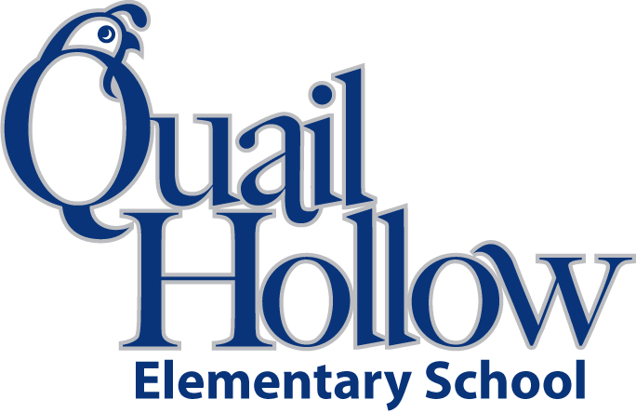

* 6 composition notebooks (wide ruled)
* 1 notebook paper (wide ruled)
* 1 binder (3 ring, 1 inch, plastic)
* 6 folders (plastic, pronged, 2 pocket, any color)
* 4 tape (transparent on dispenser)
* 1 scissors (youth size)
* 1 pack of crayons (variety color)
* 1 highlighter (yellow)
* 1 pencil bag/box (any color)
* 2 large erasers
* 2 index cards (3 by 5)
* 2 packs of sticky notes (any color)
* 3 packs of pencils (yellow, #2)
* 2 boxes of tissues
* 1 bottle hand sanitizer
* 1 lysol wipes
* 1 ear buds (place in a baggie with child’s name)

Boys only:

* 1 box of quart size baggies
* 1 package of markers

Girls only:

* 1 box of gallon size baggies
* 1 box of colored pencils

3rd Grade Supply List 2018-2019

K