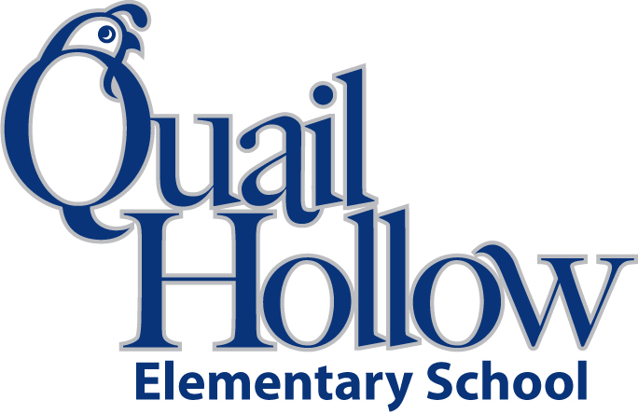

* 6 composition notebooks (wide ruled)
* 1 notebook paper (wide ruled)
* 1 binder (3 ring, 1 inch, plastic)
* 4 folders (1-red, 1-blue, 1- green, 1-orange)
* 1 scissors (youth size)
* 2 packs of crayons (variety color)
* 1 pencil bag/box (any color)
* 3 large block erasers
* 1 pack of dry erase markers
* 2 packs of sticky notes (any color)
* 3 packs of pencils (yellow, #2)
* 2 boxes of tissues
* 1 bottle hand sanitizer
* 1 Lysol wipes
* 1 ear buds (place in a baggie with child’s name)

Boys only:

* 1 box of quart size baggies
* 1 package of markers

Girls only:

* 1 box of gallon size baggies
* 1 box of colored pencils

2nd Grade Supply List 2018-2019

K