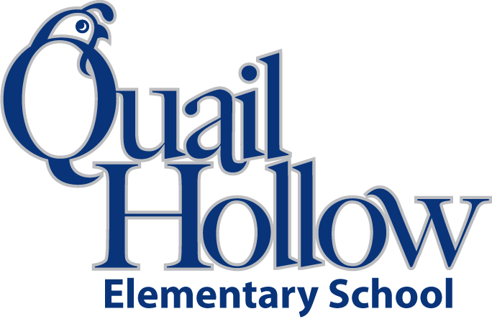

* Backpack with Child’s Name On It (Please No Wheels)
* 1 pair of scissors
* 1 Box of Crayons (24ct)
* 3 pkgs. of Erasers
* 1 Box of Colored Pencils
* 24+ #2 Pencils (Sharpened Please)
* 4 Glue sticks
* 2 Highlighters
* 2 Packs of Expo Dry Erase Markers
* 2 Black Composition Notebooks with Primary Writing Lines
* 2 Wide-ruled spiral notebooks
* 3 **Plastic** 3-Prong Pocket Folders (Yellow, Red, and Green)
* Hand sanitizer

Boys please bring:

* 2-3 Boxes of Kleenex
* 1 Box of Sandwich Size Ziploc Bags

Girls please bring:

* 1 Box of Gallon Size Ziploc Bags
* 1 Clorox Disinfecting Wipes

All items will be the community property of the class excluding the backpack. For this reason, please **do not write your child’s name** on the school supplies.

Thank you,

First Grade Team

1st Grade Supply List 2018-2019

K