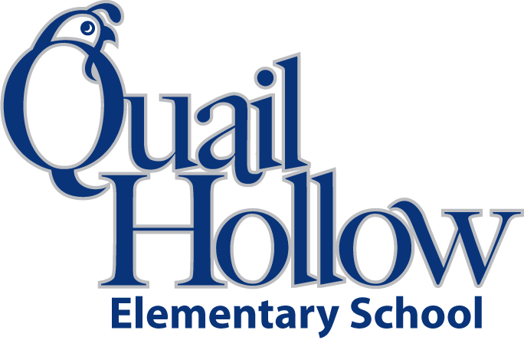

- 1 pack of 8 Crayola large crayons

- 2 multi-packs of glue sticks

- head phones (place in a baggie with child’s name)

- 2 plastic folders without prongs

- 1 white board marker

- 2 packs of baby wipes

- 1 pack AA batteries

- 2 boxes of Kleenex

- 1 backpack

- 1 bottle of Elmer’s glue

- 1 ream of white paper

- 1 package of plain, white paper plates for art projects- large or small

- 1 box of snack, quart and gallon baggies

- 1 family picture that will be laminated and put up in the class for the year

- 1 pack of diapers or pull-ups if needed. We will let you know when we are running out

- 1 small blanket for naptime. This will be sent home each week for laundering

- 1 complete change of clothes. Top, bottom, underwear, socks and shoes.

PreK Supply List 2016-2017

K