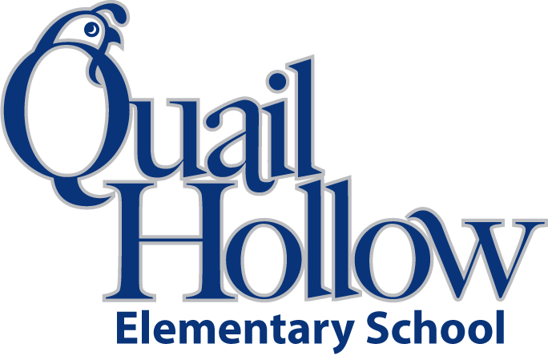

All items will be the community property of the class excluding backpacks, pencil boxes, and ear buds.

* Backpack with Child’s Name On It (Please No Wheels)
* Glue sticks (12)
* 24 Crayola crayons (2)
* Pair of scissors (1)
* 3 Plastic 3-Prong Pocket Folders (Blue, Red, and Green)
* Pencil box
* Tissues (2)
* Composition notebook (2) (**black and white only**)
* #2 pencils (1 box)
* 1 Pack of BLACK Expo Markers
* 2 Yellow Highlighters
* Large pink eraser (2)
* Refill pkg. baby wipes (1)
* Earbuds (place in a baggie labeled with child’s name)

Boys please bring:

* 1 Box of Magic Erasers
* 1 Box of Sandwich Size Ziploc Bags

Girls please bring:

* 1 Box of Gallon Size Ziploc Bags
* 1 Clorox Disinfecting Wipes

Kindergarten Supply List 2016-2017

K