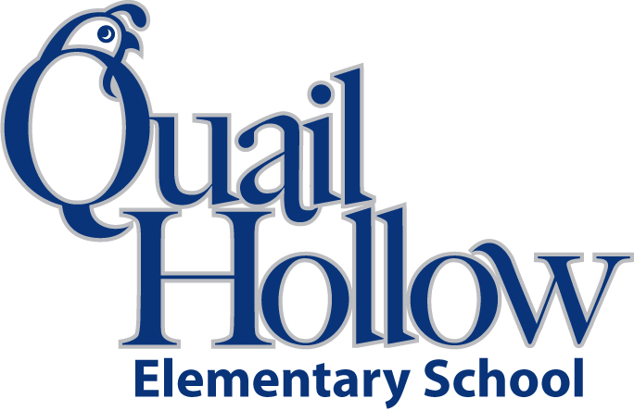

- 1 3-ring binder

- 1 set of dividers for binder

- ear buds (place in a baggie with child’s name)

- 2 packages of #2 pencils

- 2 packs of wide-ruled paper

- 4 3-prong pocket folders

- 1 white board marker

- 1 pack of markers

- 1 pack of colored pencils

- 1 handheld pencil sharpener

- 1 or 2 pink erasers or 1 package of pencil-top erasers

- 1 box of crayons

- 1 package of colored pens (variety)

- 3 highlighters (different colors)

- 4 Composition notebooks

- pencil box or binder pouch

- 8 glue sticks

- scissors

- 1 bottle of hand sanitizer

Boys only:

Box of tissues

Quart size Ziploc bags

Clorox disinfecting wipes

Girls only:

Paper towels

Gallon size Ziploc bags

Baby wipes

5th Grade Supply List 2015-2016

K