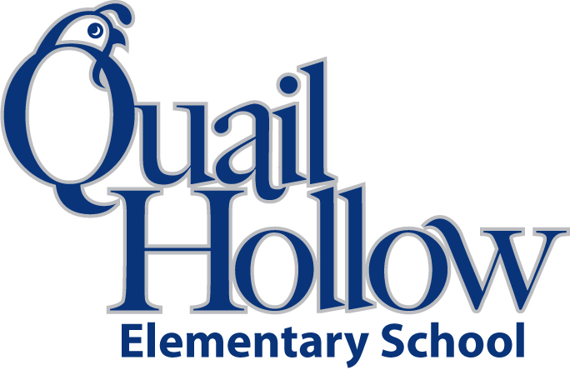

2 –Packages #2 pencils

1 - Pack of Post-It Notes

1- Pack dry erase makers

1 – Package colored pencils

1 – Pair scissors

2 – Glue sticks

2 – Package notebook paper

2 – 2-pocket folders with prongs in the middle

2 – Rolls of scotch tape

1- Box baggies sandwich or gallon

1 – Box tissues

3 – Composition notebooks (please no spiral notebooks)

2 – Packages of highlighters

1 – 1 or 2 inch binder

1 – Plain colored t-shirt

1- Backpack

*\*\*Please only put your child’s name on his or her backpack and pencil box\*\**

4th Grade Supply List 2016-2017

K