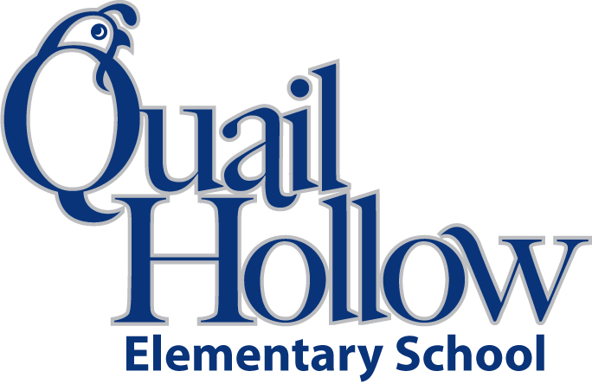

* 3 spiral notebooks (wide ruled, 70 pages or more)
* 2 composition notebooks (wide ruled)
* 1 notebook paper (wide ruled)
* 1 binder (3 ring, 1 inch, plastic)
* 3 folders (plastic, pronged, 2 pocket, any color)
* 4 tape (transparent on dispenser)
* 1 scissors (youth size)
* 1 colored pencils or crayons (variety color pack)
* 1 highlighter (any color, any type)
* 1 pencil bag/box (any color)
* 1 pack of pencil topper erasers
* 1 large eraser
* 2 index cards (3 by 5)
* 1 pack of sticky notes (any color)
* 2 packs of pencils (yellow, #2)
* 1 box of tissues
* 1 bottle hand sanitizer
* 1 lysol wipes
* 1 ear buds (place in a baggie with child’s name)

Boys only:

* 1 box of quart size baggies

Girls only:

* 1 box of gallon size baggies

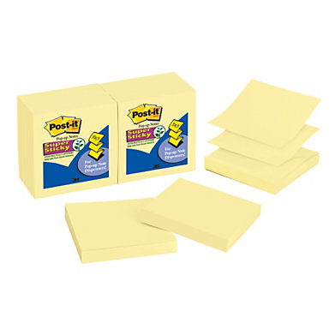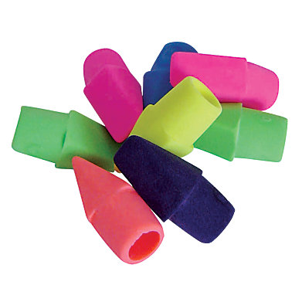

3rd Grade Supply List 2015-2016

K