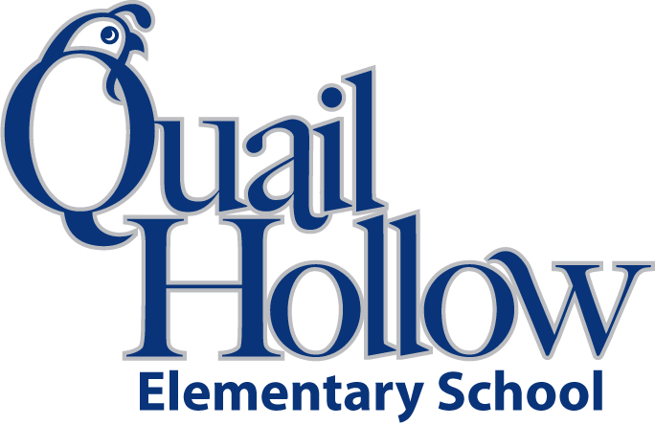

* Backpack with Child’s Name On It (Please No Wheels)
* 1 pair of scissors
* 1 Box of Crayons (24ct)
* 2 pkgs. of 3 Pink Erasers
* 1 Box of Colored Pencils
* 1 Box of Markers
* 2 pkgs. #2 Pencils (Sharpened Please)
* 2 Glue sticks
* 2 Yellow Highlighters
* 1 Pack of Chisel Tip Dry Erase Markers
* 1 Pack of Fine Point Dry Erase Markers
* 1 White Binder with Clear Cover (1 inch)
* 1 Black Composition Notebooks with Primary Writing Lines
* 2 Wide-ruled notebooks
* 3 Plastic 3-Prong Pocket Folders (Blue, Red, and Green)
* Pencil Box (labeled with child’s name)
* Earbuds (in baggie labeled with child’s name)

Boys please bring:

* 2 Boxes of Kleenex
* 1 Box of Sandwich Size Ziploc Bags

Girls please bring:

* 1 Box of Gallon Size Ziploc Bags
* 1 Clorox Disinfecting Wipes

All items will be the community property of the class excluding, pencil box, backpack, and Earbuds.

1st Grade Supply List 2016-2017

K